CISCO ISE Login Page

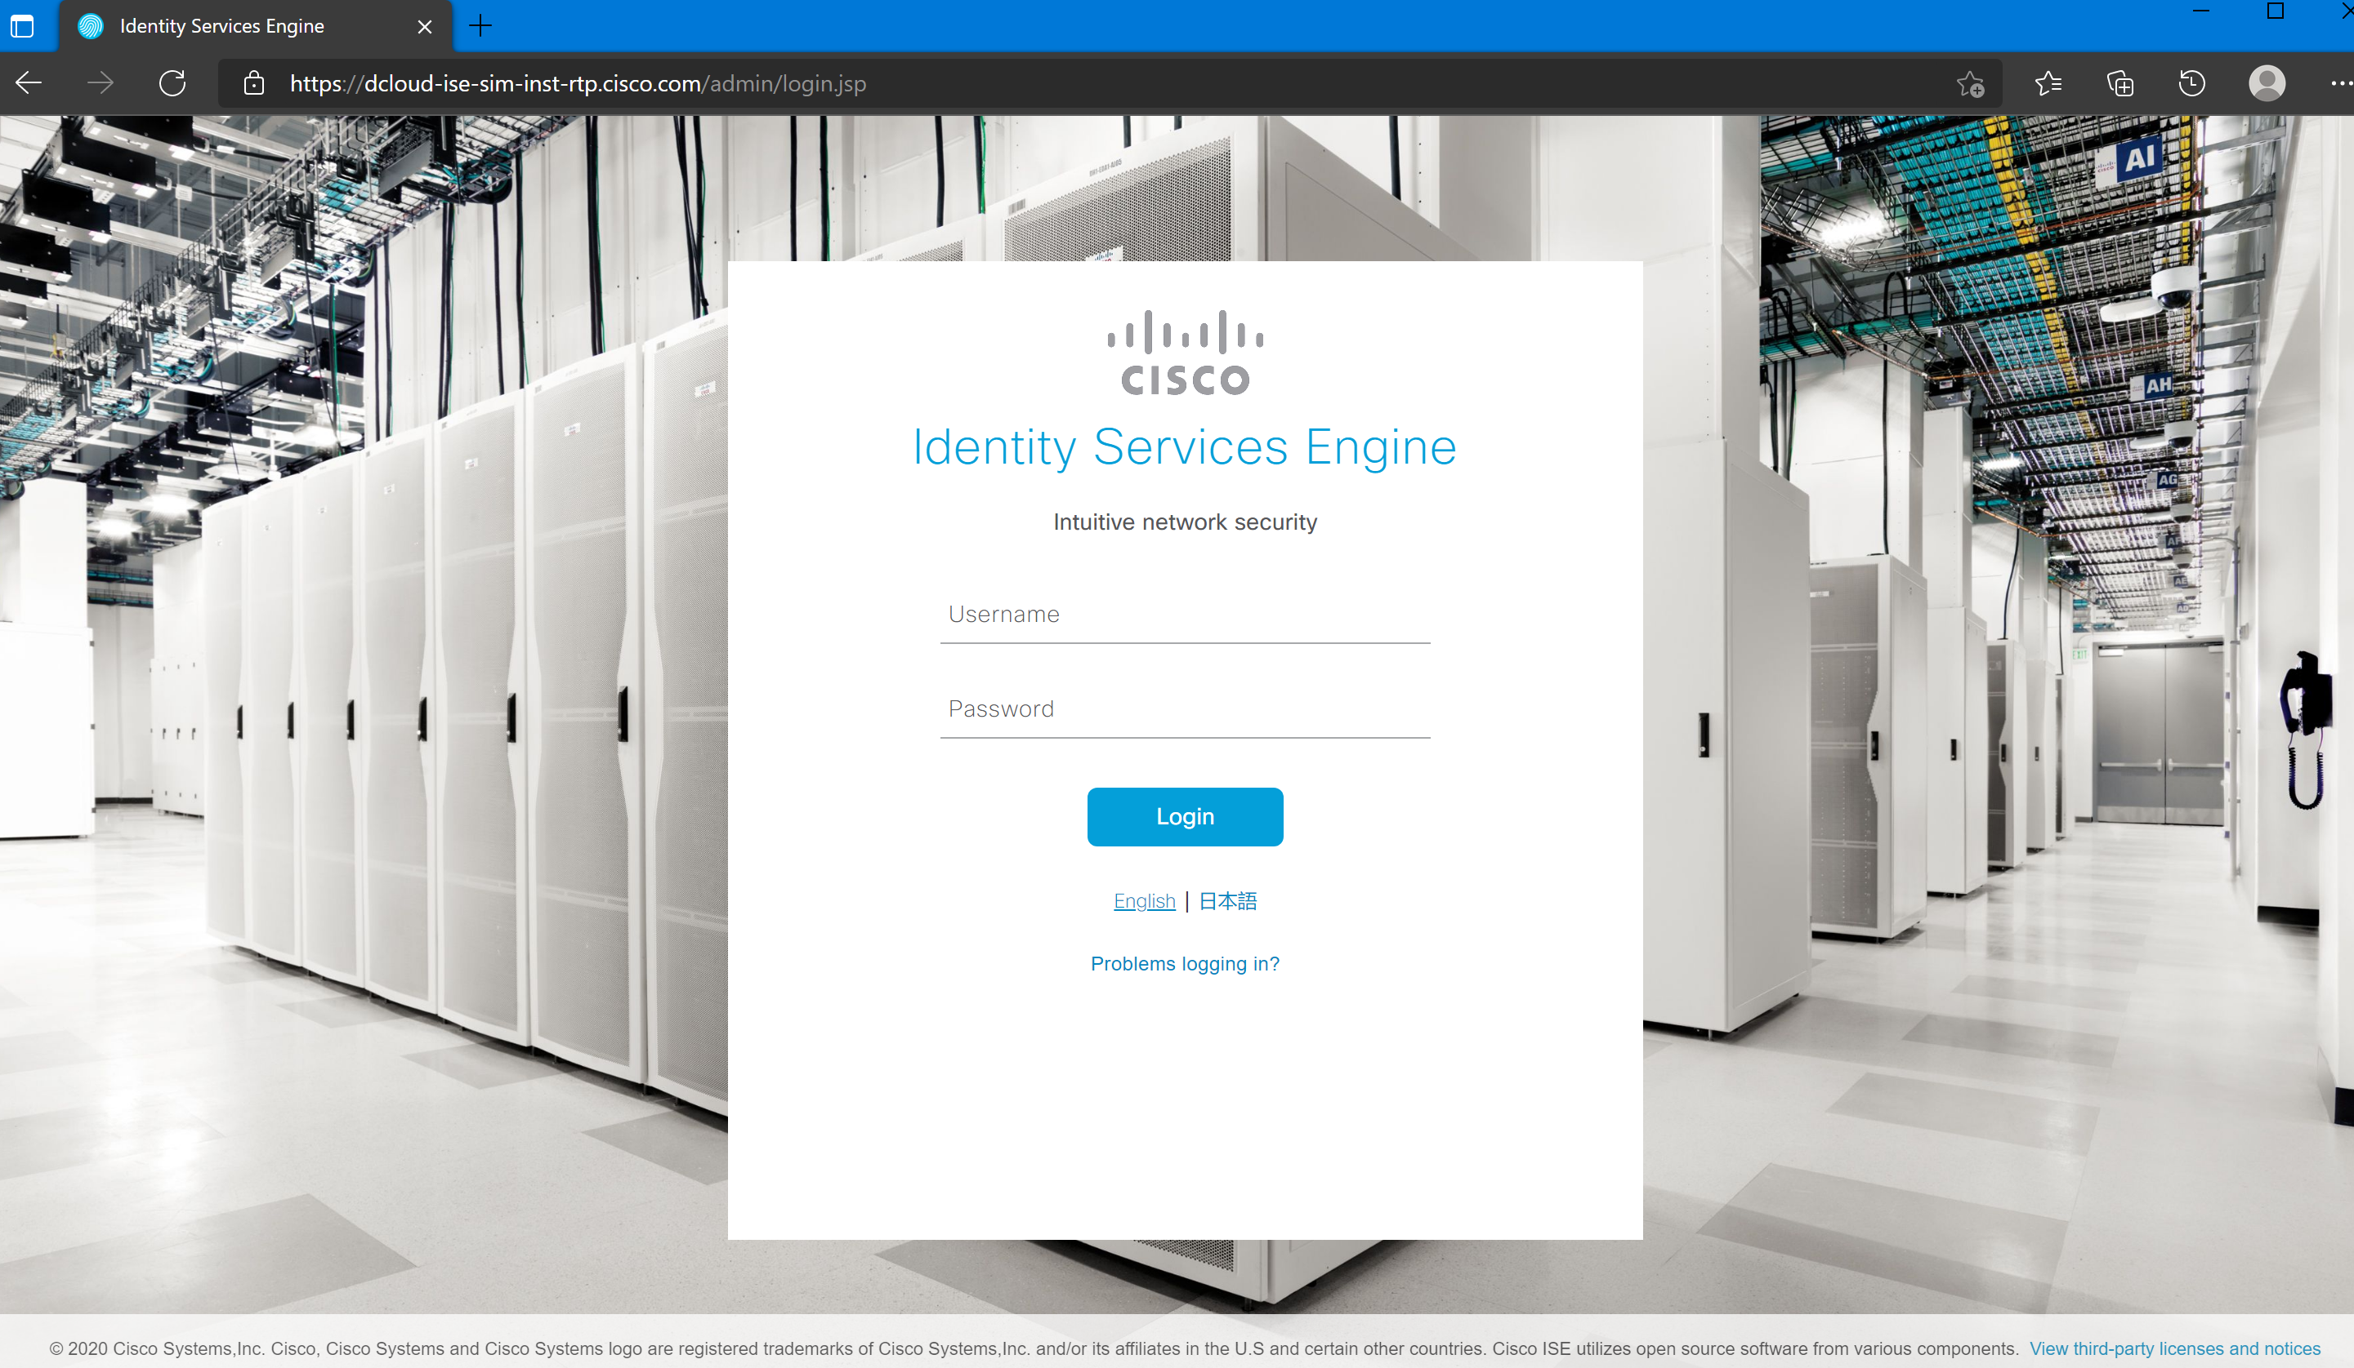

APM Portal Access object for CISCO ISE Successful Login

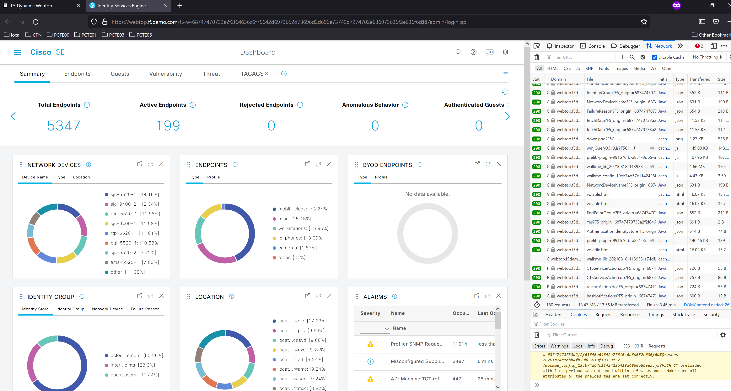

APM Portal Access Item configuration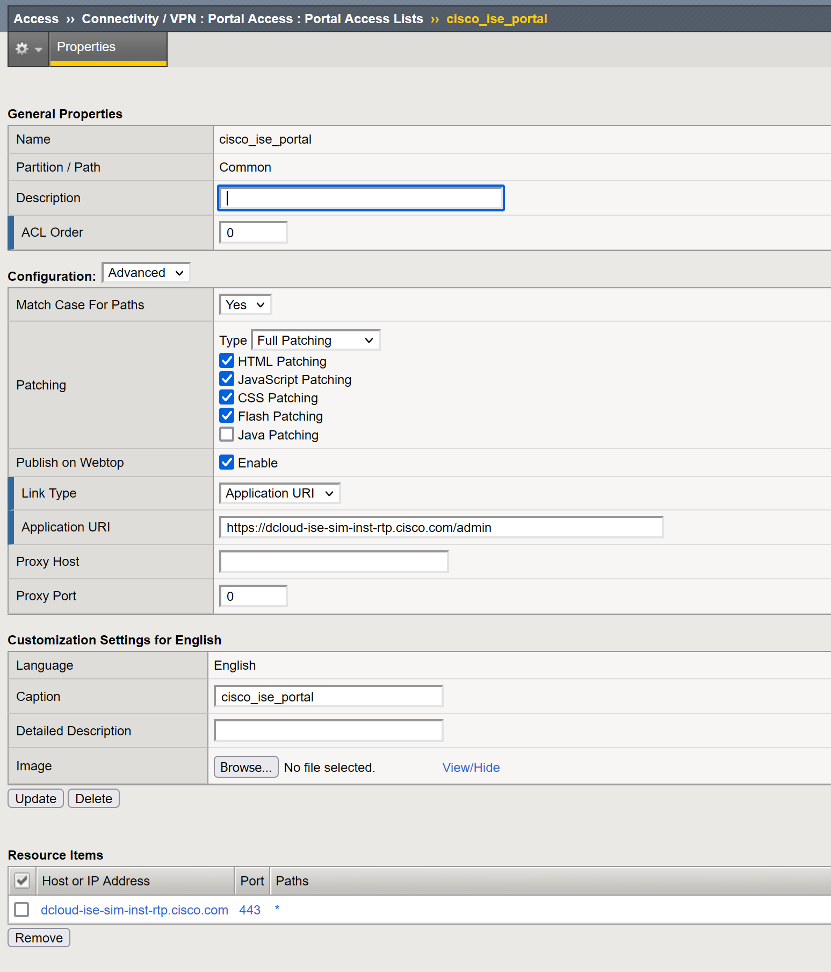

APM Portal Access Resource item

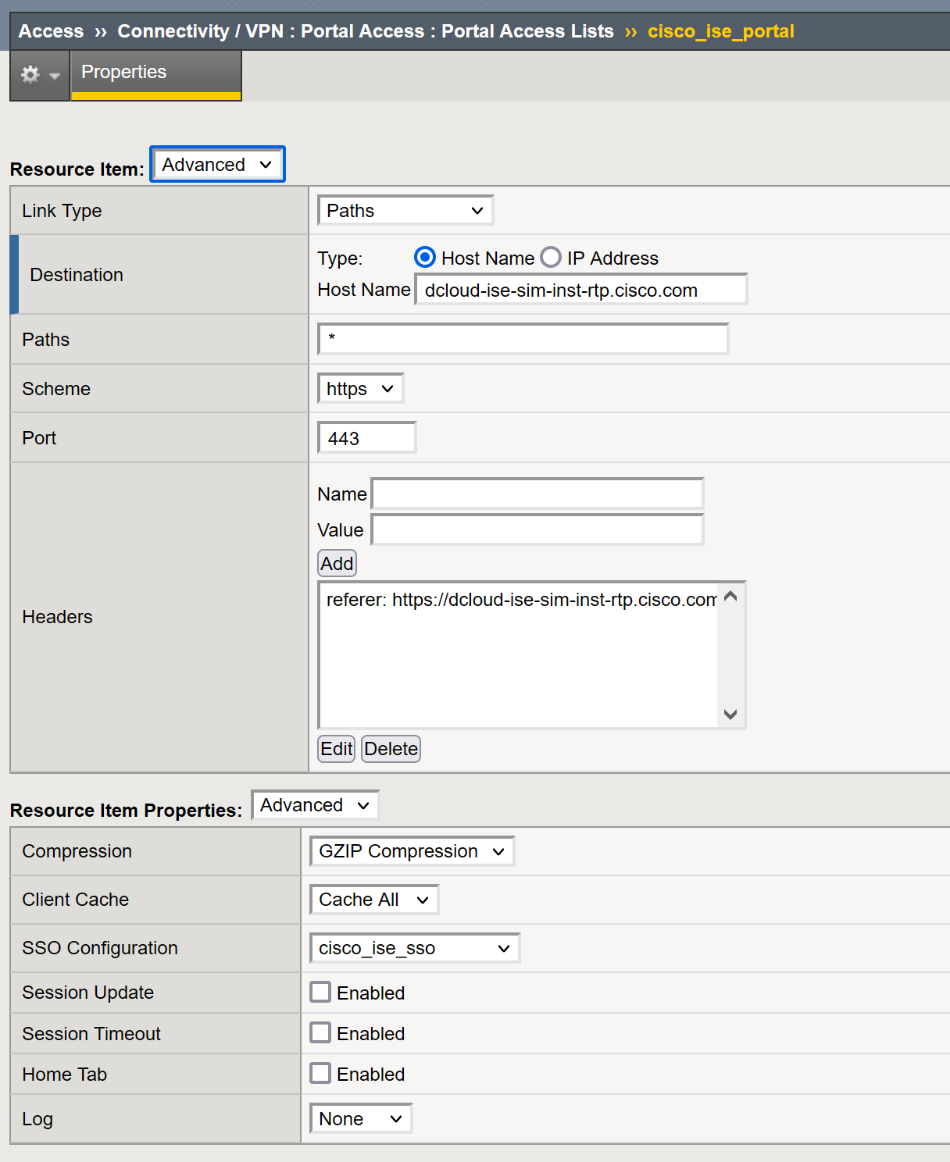

Forms based SSO configuration